Building and Strengthening Disaster Readiness Among Neighbors

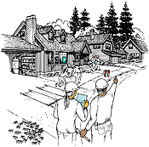
Remember…
Immediately following disasters, follow the 9 Steps described in this booklet.

Neighborhood
2013

Map Your Neighborhood – MYN
With thanks to Washington State Emergency Management, Public Educations

Sponsors:

Emergency Preparedness
Make a Plan
Many disasters happen without warning. Take the time to plan how to protect and provide for yourself, your family and your pets in the event of an emergency or disaster. It is critical that your household is taken care of before you are able to assist your neighborhood.
A plan should have three important things:
●   A Meeting Place - Pick a location within walking distance of your home where your family members can meet in case you get separated or have to evacuate. (For example, a local park or playground.)
●    An Out-of-Area Contact - During a disaster, you may not be able to make local phone calls, but you CAN call out of the area. Pick a family member or friend to serve as your family’s Out-of-Area contact. In the event of an emergency or disaster, you can call your Out-of-Area contact and tell them you’re safe, where you are and where you are going.
Your Out-of-Area contact can then share this information with other family members who call. All family members should have the phone number of your Out-of-Area contact with them at all times.

Family meeting place away from home

Out-of-Area contact person and telephone
Each family member should carry this information at all times.
●   An Emergency Supply Kit - Enough supplies to last you three days as a minimum, but for even longer is better! Build a kit for your home, for your car and for your work. And remember to make sure your child is prepared at school.

Build a Kit
During a large disaster it may take at least three days or more for emergency officials to deploy necessary resources. First responders may not be able to get to you even if you call 9-1-1. As a result, you and your family need to build a 5 – 7 day (2 wks if possible) Emergency Supply Kit so you can stay safe in case of disaster. Put together small versions for the office, school and car.
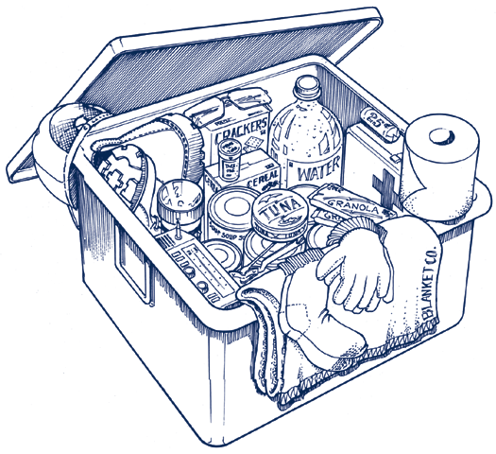
Here’s what you need:
- Water: 1 gallon per person per day
- Food: non-perishable canned goods with can opener, granola bars, protein bars, and “comfort” foods like cookies or hard candy.

- NOAA Tone Alert Weather radio
- Extra set of clothes with sturdy shoes
- Flashlight with extra batteries or light stick
- Whistle
- First aid kit including a three-day supply of prescription drugs
- Entertainment items like book, games.
- Shelter-in-Place supplies like duct tape and plastic
- Cash: ATMs won’t operate if power is out

Remember, emergency supply kits should be designed to fit your needs.

Introduction to Map Your Neighborhood
In a disaster, your most immediate source of help are the neighbors living around you. In this workbook you will:
- Learn the first 9 Steps to take immediately following disaster to secure your home and to protect your neighborhood. It is hard to think clearly following disaster. These steps will help you quickly and safely do things that help.
- Identify the skills and equipment each neighbor has that are useful in an effective disaster response. Knowing which neighbors have supplies and skills helps your disaster response be timely, and allows everyone to contribute to the response in a meaningful way.
- Create a Neighborhood Map showing the locations of:
- Each natural gas meter and propane tank. About 67% of house fires following earthquakes are caused by leaking gas. Knowing where these meters are and shutting them off helps eliminate this threat.

- Each neighbor who is elderly, who has disability and where children are who may be home alone at certain hours of the day. Checking on neighbors vulnerable to injury and trauma helps protect them from going into shock, and helps ensure that everyone is okay.

9 Steps — Immediately Following Disaster
AT HOME...
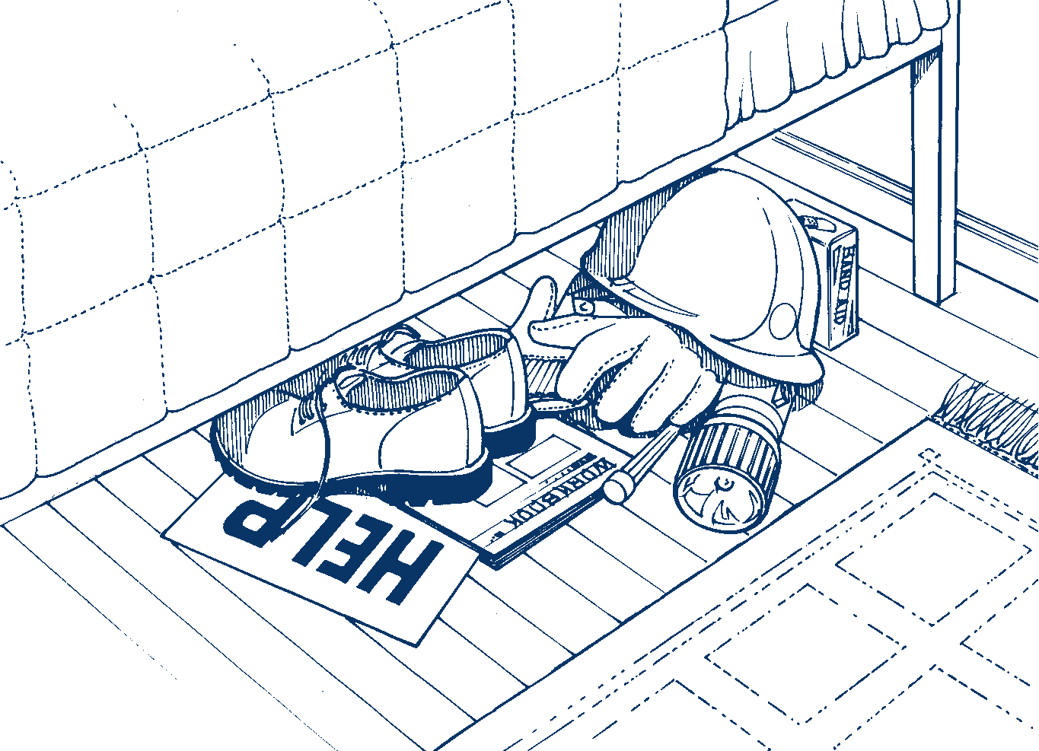
Step 2: Keep these under your bed.
Step 1. Take care of your loved ones.
Step 2. Take a moment to size-up the situation. A bicycle helmet or hardhat protects from falling debris. Sturdy shoes protect from broken glass. Leather gloves protect from sharp objects.
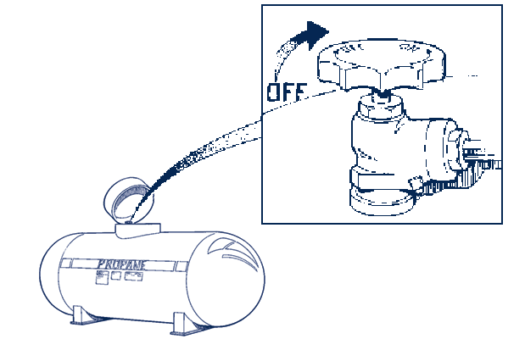
Step 3. Check the natural gas or propane at your home. Shut off if necessary. This is one of the best ways to prevent fire.
Step 3
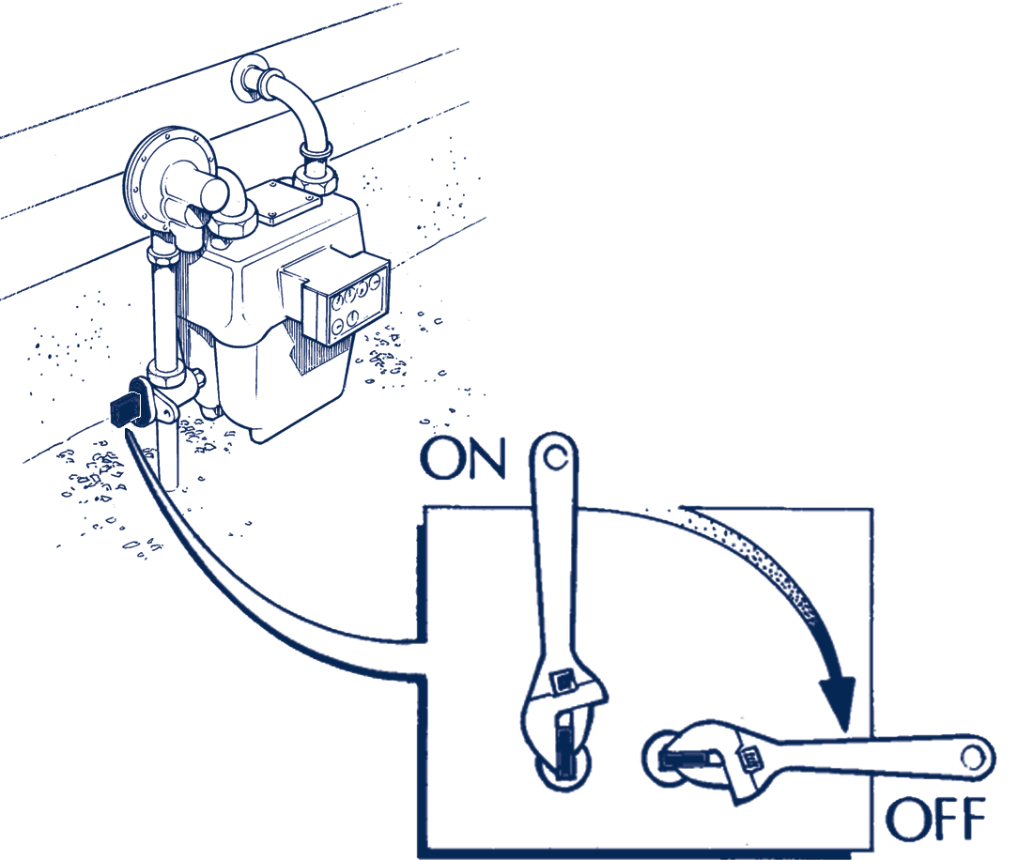
Step 4. Shut off water at the house main, if necessary, to trap water in your home and to keep pollutants out of possible drinking water, like that in your water heater.
Step 5. Place the Help or OK sign (see back page) on your front door or window. Posting the sign helps your neighbors locate those who need help first.
Step 6. Get your emergency supplies (72-hour kit) and turn on your radio for emergency communications. Don’t leave your household until everyone understands what is happening and has the supplies they need.
Turn the valve 1/4 turn to shut off the gas. NEVER turn it back on once it has been turned off.

Your Neighborhood Contact List (may continue on next page)

HOUSE 1
Adult Name(s)
Children Name(s)
Best Phone
Email
Pet(s) and kind(s)
Any person with specific needs

HOUSE 2
Adult Name(s)
Children Name(s)
Best Phone
Any person with specific needs

Email
Pet(s) and kind(s)
HOUSE 3
Adult Name(s)
Children Name(s)
Best Phone
Email
Any person with specific needs

Pet(s) and kind(s)
HOUSE 4
Adult Name(s)
Children Name(s)
Best Phone
Email
Pet(s) and kind(s)
Any person with specific needs

HOUSE 5
Adult Name(s)
Children Name(s)
Best Phone
Email
Pet(s) and kind(s)
HOUSE 6
Any person with specific needs

Adult Name(s)
Children Name(s)
Best Phone
Any person with specific needs

Email
Pet(s) and kind(s)
HOUSE 7
Adult Name(s)
Children Name(s)
Best Phone
Email
Any person with specific needs

Pet(s) and kind(s)
HOUSE 8
Adult Name(s)
Children Name(s)
Best Phone
Email
Pet(s) and kind(s)
Any person with specific needs

HOUSE 9
Adult Name(s)
Children Name(s)
Best Phone
Email
Pet(s) and kind(s)
Any person with specific needs

HOUSE 10
Adult Name(s)
Children Name(s)
Best Phone
Any person with specific needs

Email
Pet(s) and kind(s)
HOUSE 11
Adult Name(s)
Children Name(s)
Best Phone
Email
Any person with specific needs

Pet(s) and kind(s)
HOUSE 12
Adult Name(s)
Children Name(s)
Best Phone
Email
Pet(s) and kind(s)
Any person with specific needs

HOUSE 13
Adult Name(s)
Children Name(s)
Best Phone
Email
Pet(s) and kind(s)
Any person with specific needs

HOUSE 14
Adult Name(s)
Children Name(s)
Best Phone
Any person with specific needs

Email
Pet(s) and kind(s)
HOUSE 15
Adult Name(s)
Children Name(s)
Best Phone
Email
Any person with specific needs

Pet(s) and kind(s)
HOUSE 16
Adult Name(s)
Children Name(s)
Best Phone
Email
Pet(s) and kind(s)
Any person with specific needs

HOUSE 17
Adult Name(s)
Children Name(s)
Best Phone
Email
Pet(s) and kind(s)
HOUSE 18
Any person with specific needs

Adult Name(s)
Children Name(s)
Best Phone
Any person with specific needs

Email
Pet(s) and kind(s)
HOUSE 19
Adult Name(s)
Children Name(s)
Best Phone
Email
Any person with specific needs

Pet(s) and kind(s)
HOUSE 20
Adult Name(s)
Children Name(s)
Best Phone
Email
Pet(s) and kind(s)
Any person with specific needs

HOUSE 21
Adult Name(s)
Children Name(s)
Best Phone
Email
Pet(s) and kind(s)
Any person with specific needs

HOUSE 22
Adult Name(s)
Children Name(s)
Best Phone
Any person with specific needs

Email
Pet(s) and kind(s)
HOUSE 23
Adult Name(s)
Children Name(s)
Best Phone
Email
Any person with specific needs

Pet(s) and kind(s)
HOUSE 24
Adult Name(s)
Children Name(s)
Best Phone
Email
Pet(s) and kind(s)
Any person with specific needs

WITH NEIGHBORS…

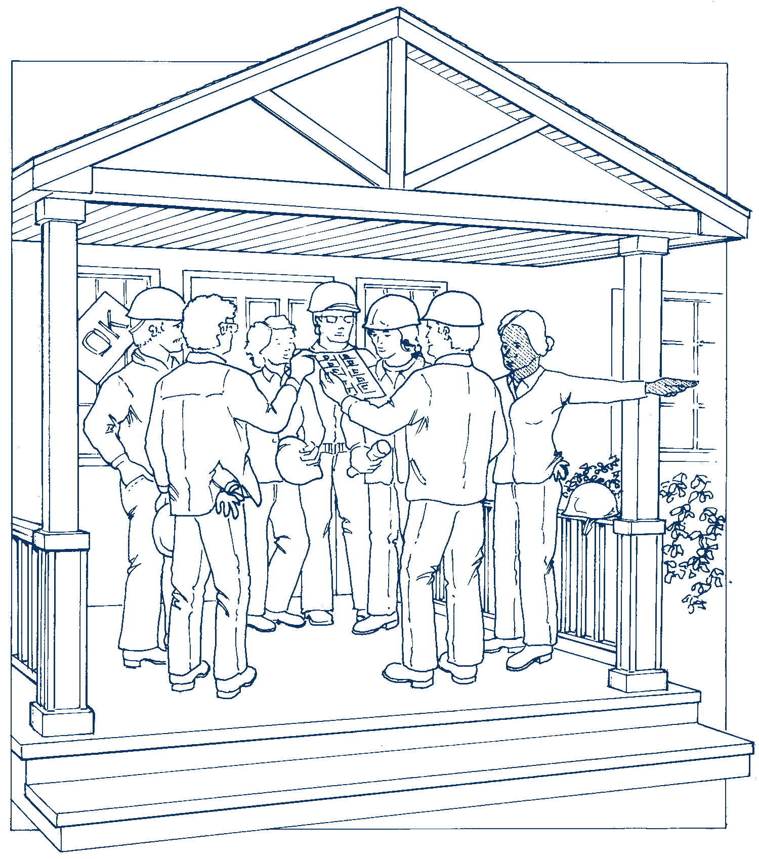
Step 7. After Steps 1-6 are completed, go to the Neighborhood Gathering Site. (The following page will help you choose this location.)

Write your Neighborhood Gathering Site location here:

Step 8. Form Teams at the Neighborhood Gathering Site:
- Team 1 will listen to the Emergency Alert System (AM/FM radio), or to a NOAA Weather Radio and where possible an amateur radio to keep neighbors informed of what they learn.
- Team 2 will check on neighbors who are elderly, those with disability, or children who may be home alone.
- Team 3 will check all natural gas meters and propane tanks, and shut off the gas as necessary.
- Team 4 will check on all homes with the “Help” card displayed on the front door or window, or with no card showing. Be prepared to give first aid. Trust your instincts. If something feels unsafe, stay out.
Step 9. Go back to the Neighborhood Gathering Site after your Team has completed its work. Share what you have done with the rest of your neighbors.

Neighborhood Gathering Site and Care Center
Neighborhood Gathering Site:
Come to the Neighborhood Gathering Site after you have completed Steps 1-6 of “9 Steps Immediately Following Disaster.” Coming here will help you organize an effective neighborhood response, and reduce confusion.
The Neighborhood Gathering Site is a location some place in the neighborhood where neighbors can gather once they have determined their loved ones and homes are okay. It is important that it is easily seen, as the visibility will help remind everyone that they should come here. It may be at someone’s home on a large front porch, a covered carport, or an open garage, which will protect you from rain or snow.
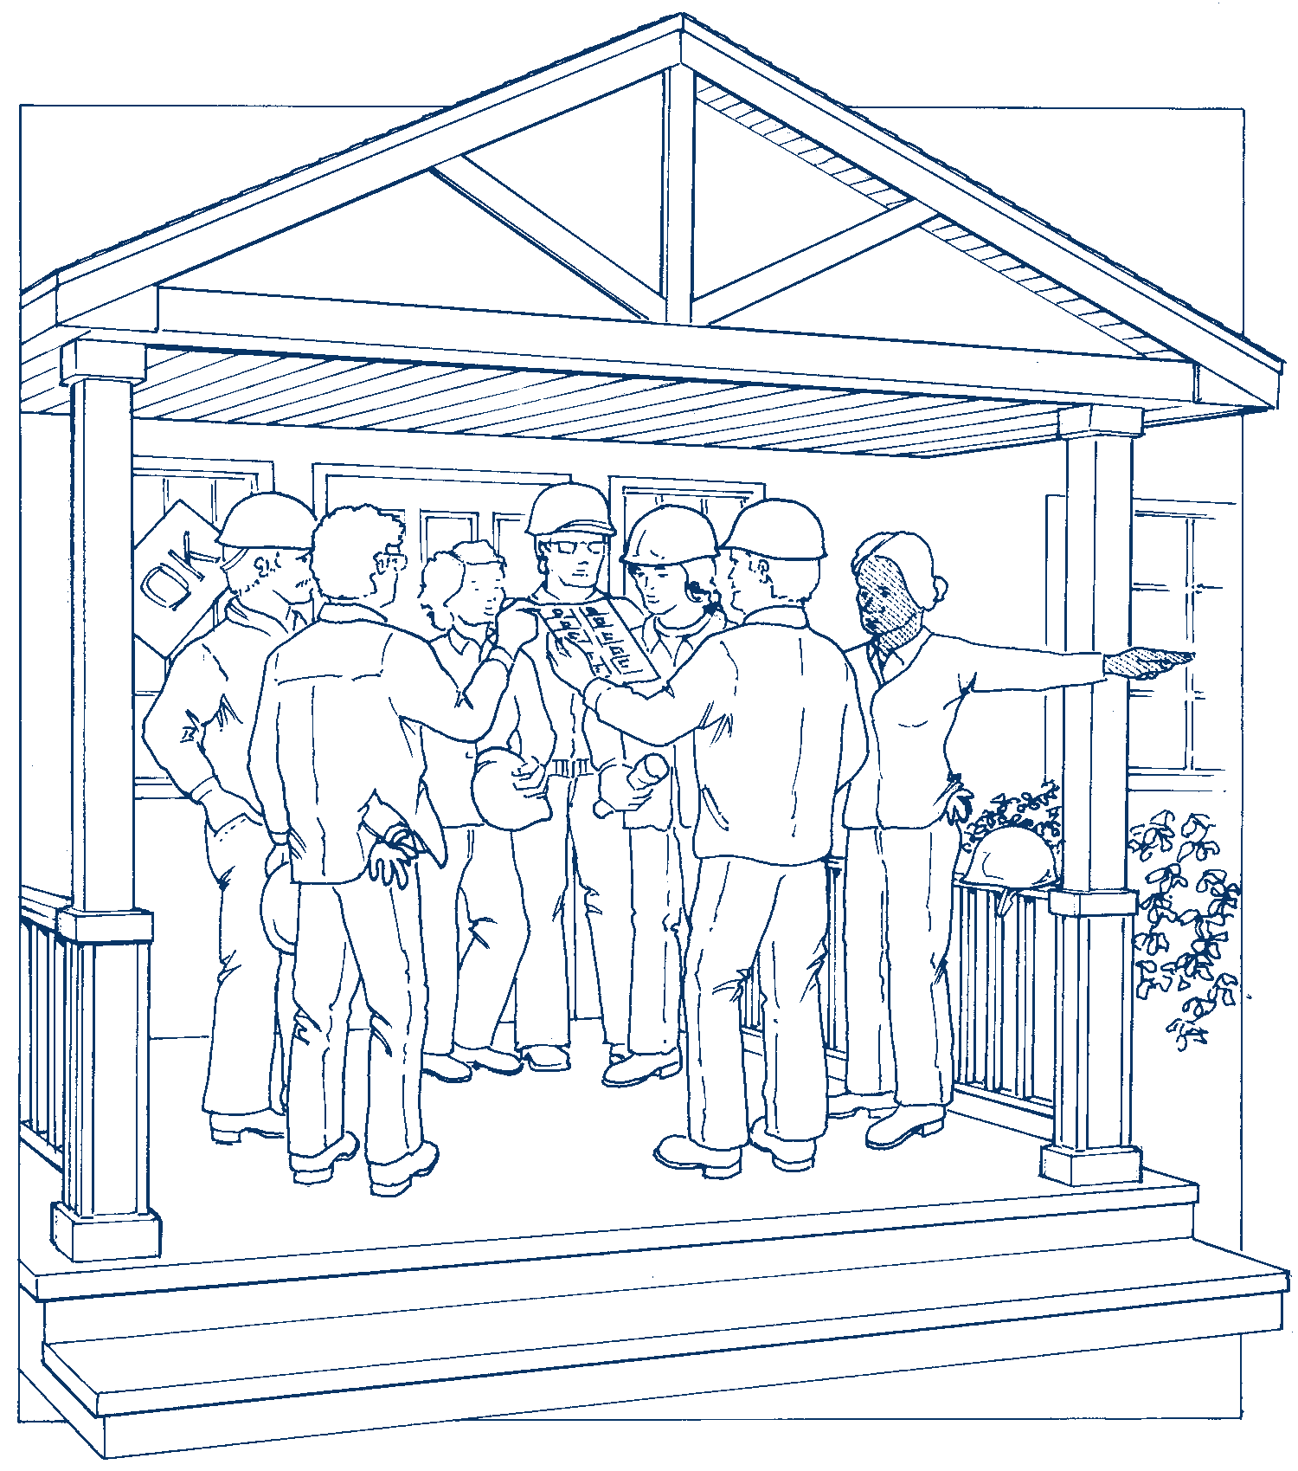
Write your Neighborhood Gathering Site here (please also write this location in the box on the previous page):

Neighborhood Care Center:

A Neighborhood Care Center is inside someone’s home. It is a place where children, those who are elderly and those with disability can be brought so they are not alone and where they can be given care.
Write your Neighborhood Care Center location here:

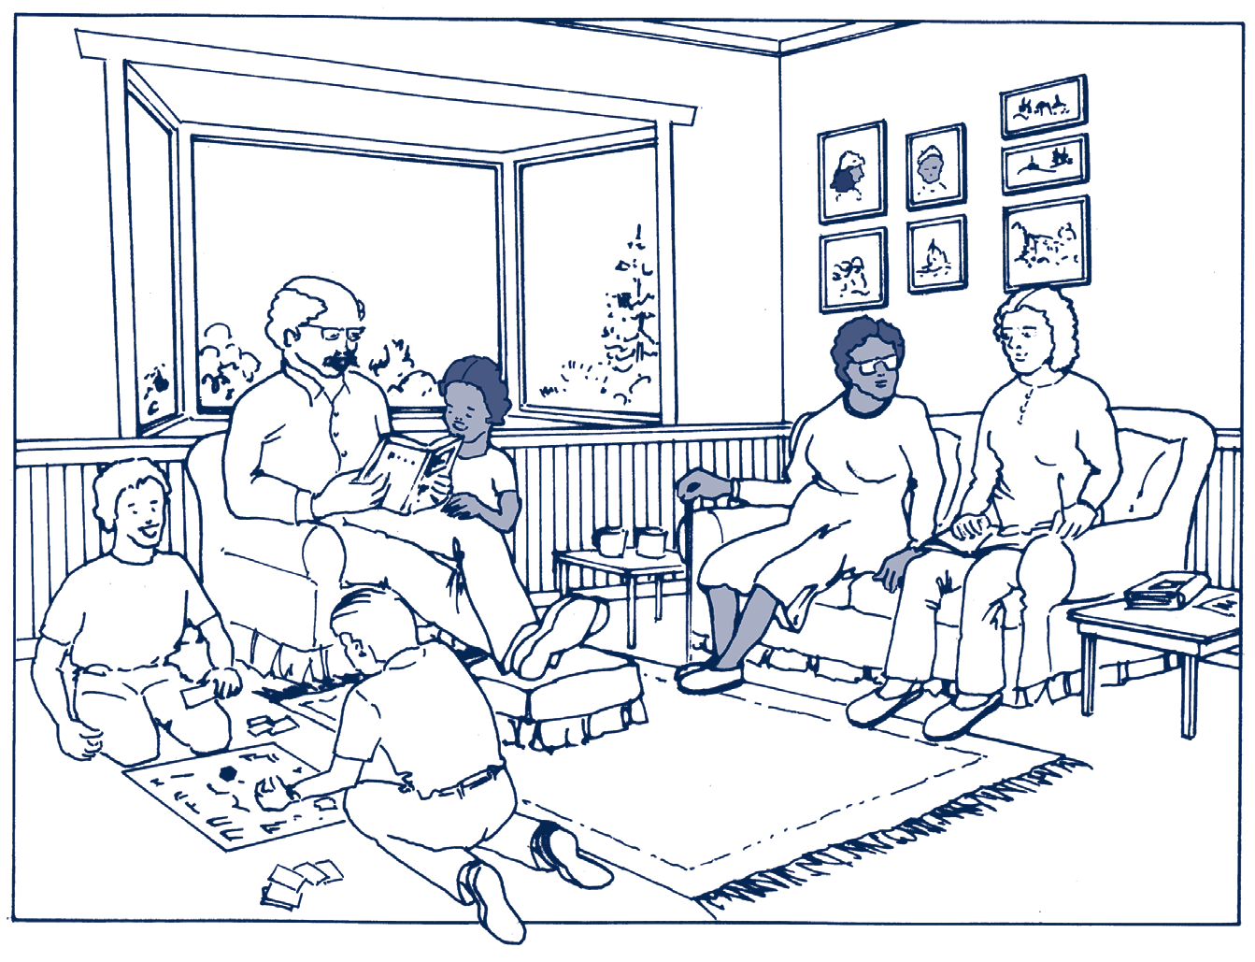

Guidelines for Neighborhood Mapping
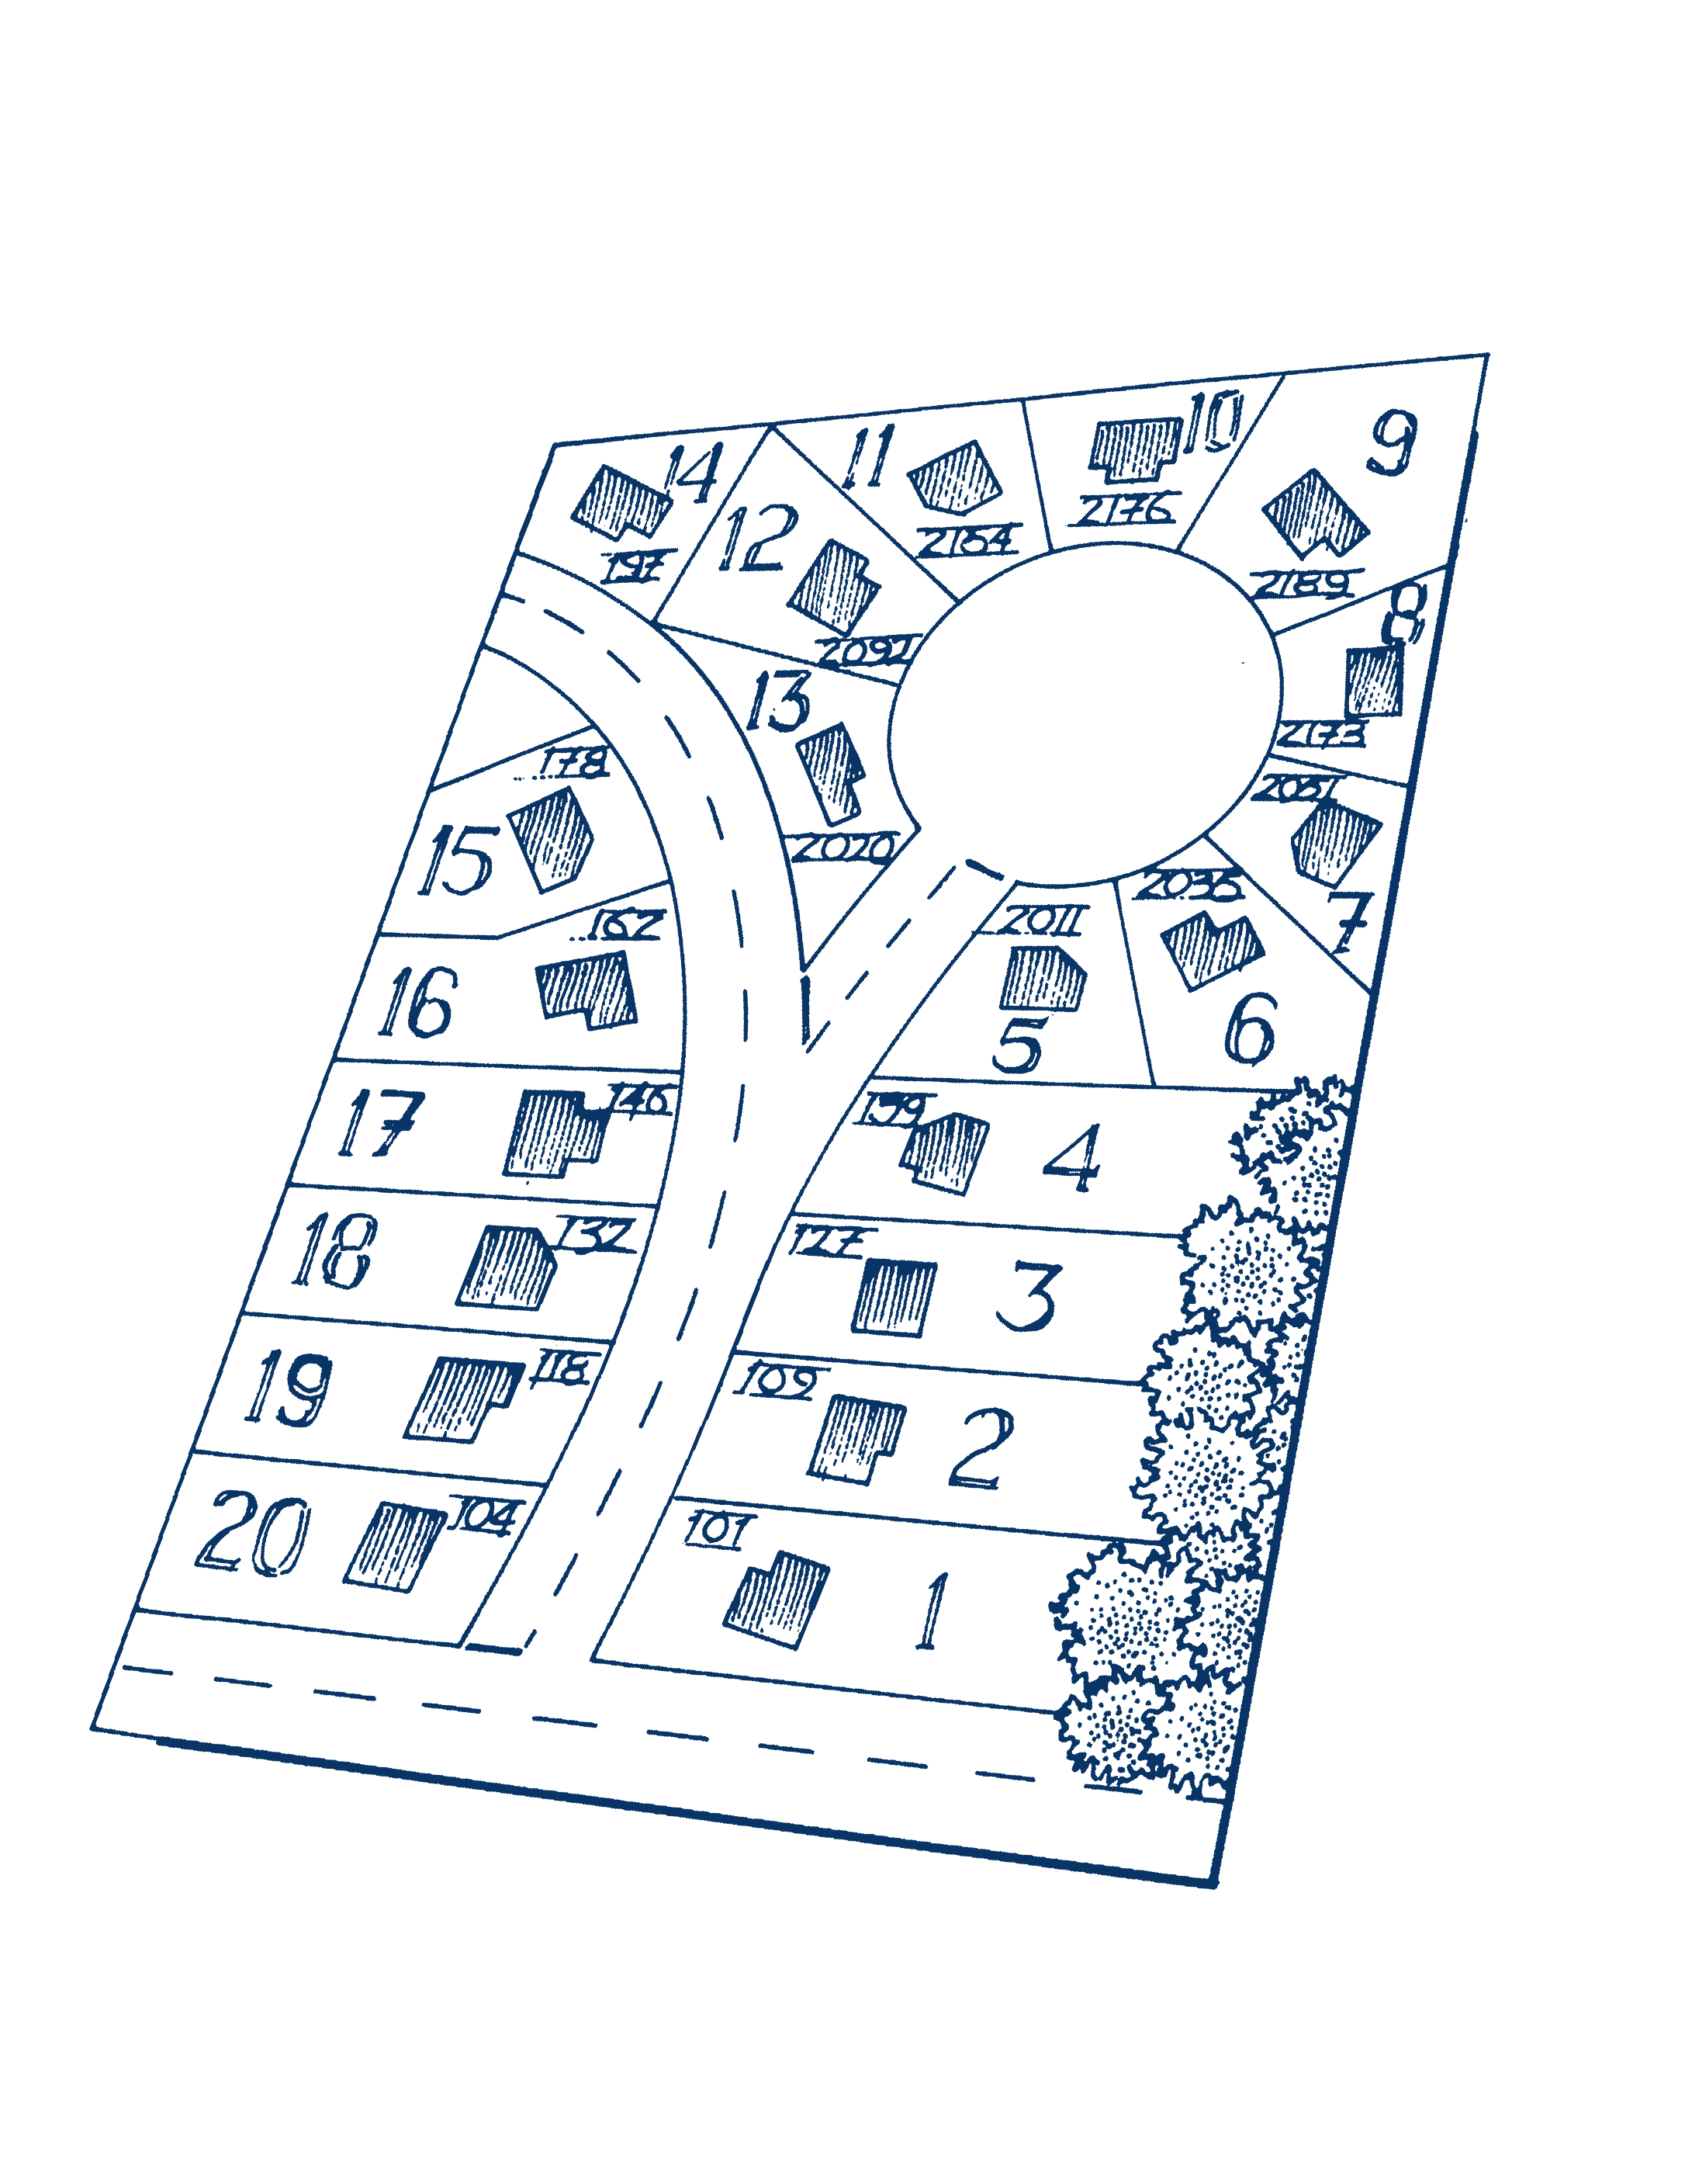
These guidelines will help you sketch a neighborhood map (create the sketch on the following page).
House numbers


FIRST:
Building lot numbers
Sketch the basic layout of your neighborhood.
  Include streets, building lots and houses.
  Include house numbers.
SECOND:
Number the building lots in order. This will allow you to easily match each house to the information on the
Contact List (see FOURTH step).
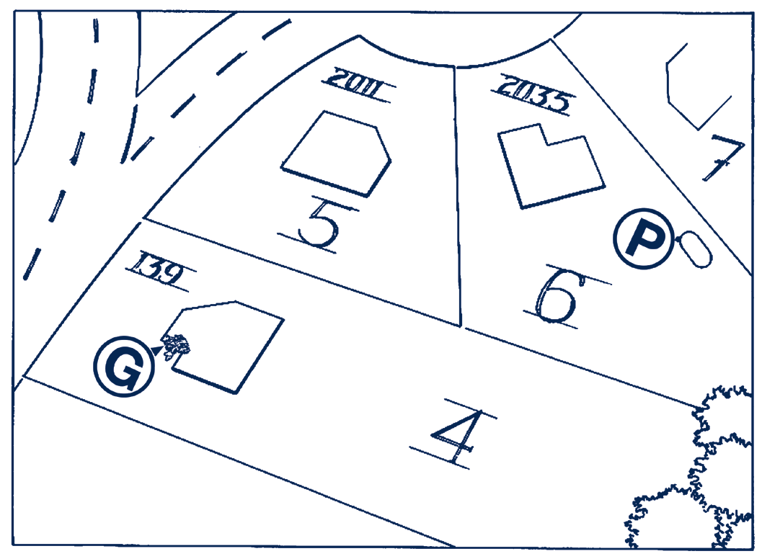
THIRD:
Propane indicator
Mark the exact location of each natural gas meter or propane tank on your map.
-  Explain the location of your gas meter to your neighbors. For example, “behind the lilac bush on the front corner of the house.”
 Suggestion: At the end of the meeting, actually walk your neighborhood and identify each meter. It is useful to see where each meter is located.
Gas indicator

FOURTH:
 In the tinted box on the Contact List, write names of those who may need extra help during disasters (neighbors who are elderly, neighbors with disability and children who may be home alone at certain hours of the day).
 Match on contact list with the lot that you numbered “1,” match with the lot that you numbered “2,” match with “3,” match with “4,” etc.

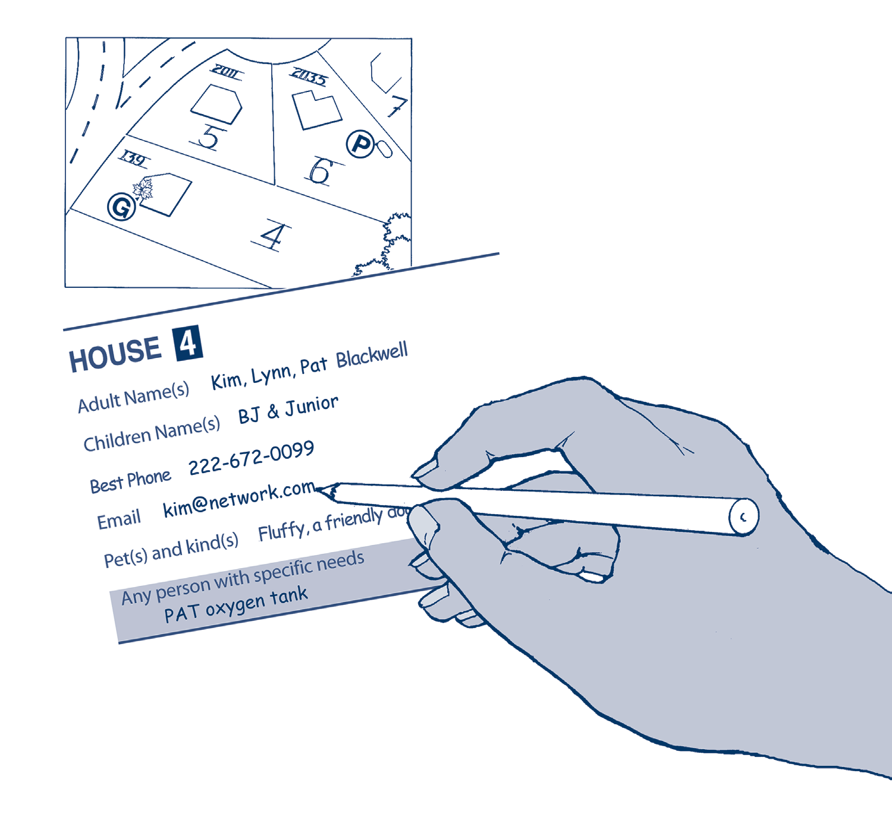

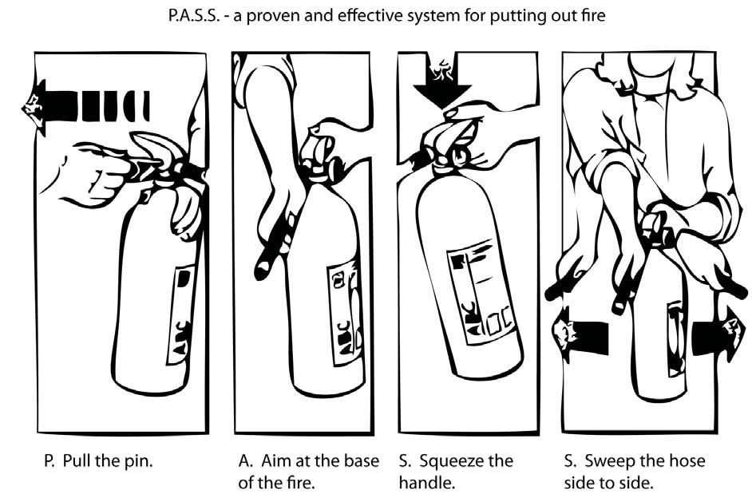
In the next 48 hours, complete the Contact List as shown above.
Neighborhood Skills and Equipment Inventory

Who knows what? Who has what? Who can do what? Write the names of neighbors with these skills/knowledge and equipment/supplies:


SKILLS / KNOWLEDGE
First Aid Skills

Child Care Skills

Elder Care Skills

Search and Rescue Skills

Crisis Counseling Skills

Plumber Skills

Carpenter Skills
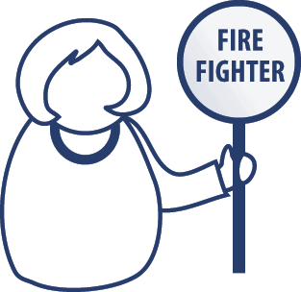
Electrician Skills

Emergency Response Skills

Coordinating and Organizing Skills

Language Skills
EQUIPMENT / SUPPLIES
First Aid Supplies

Tents / Spare Bedding

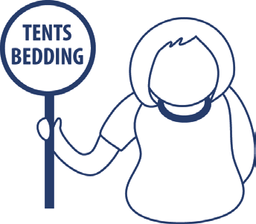
Chain Saw

Generator (use with caution)

Fire Extinguisher

Camp Stove

Ham Radio/Walkie-Talkie

NOAA Weather Radio

Ladder

Crow Bar

Strong Rope



