1) NVIS AS-2259 Antenna
By Mike Melland, W9WIS
Adaptions in red by Tom McCombs, N6WTM
(There are two documents: 1) the original DIY AS-2259 Antenna using a tuner and 2) modifications with coils without a tuner. At the end are pictures of my adaptions)
I became interested recently with the concept of NVIS (Near Vertical Incidence Skywave) Antennas. The NVIS antenna is ideal for local and emergency communications on HF.
Portability and their unique performance envelope make them worth looking at for any amateur serious about reliable HF communications. Probably the biggest users of NVIS antennas are the military and FEMA.
What is NVIS?
"NVIS, or Near Vertical Incidence Skywave, refers to a radio propagation mode which involves the use of antennas with a very high radiation angle, approaching or reaching 90 degrees (straight up), along with selection of an appropriate frequency below the critical frequency, to establish reliable communications over a radius of 0 - 300 miles or so, give or take 100 miles. Although not all radio amateurs have heard the term NVIS, many have used that mode when making nearby contacts on 160 meters or 80 meters at night, or 80 meters or 40 meters during the day. They may have thought of these nearby contacts as necessarily involving the use of groundwave propagation, but many such contacts involve no groundwave signal at all, or, if the groundwave signal is involved, it may hinder, instead of help. Deliberate exploitation of NVIS is best achieved using antenna installations which achieve some balance between minimizing groundwave (low takeoff angle) radiation, and maximizing near vertical incidence skywave (very high takeoff angle) radiation."
The paragraph above is an excerpt from an excellent source of technical information on NVIS principles, which can be found here thanks to James Glover, WB5UDE. Another special thank you is due Dr. Carl Jelinek, N6VNG whose NVIS antenna construction article written in 1998 is the basis for this project.
The most famous of the NVIS military antennas... recently in use during the War in Iraq by US Forces... is the AS-2259 NVIS antenna, manufactured originally by Collins Radio (Model 637-K1) and now by Telex Wireless (Model 1990) as well as Harris Communications (Model RF-1936). The most interesting thing about the AS-2259 is that the hollow 1.25" tube that makes up it's mast also serves as a low loss feed line. Here is the Army Technical Manual for the AS-2259/GR Antenna.
In the pages that follow I'll walk you through construction of a "homebrew" version of the famous AS-2259!
Build Your Own AS-2259 Type NVIS Antenna
Parts List
3 ea 1.5" PVC pipes 5' long
2 ea 1.5" PVC coupling 2 ea
1.5" PVC cap 1 ea
1.5” PVC plug 1 ea
egg type insulators
3 ea brass round head screws (1/2" 6-32)
2 ea brass round head screw (1" 6-32)
4 ea lock washers for 6-32 screws
6 ea brass hex nuts (6-32)
4 ea flat #6 brass washers
1 ea SO-239 chassis connector with solder pot center pin
1 ea SO-239 coax crimp on type 4 ea stakes
1 ea round metal stake 3/4" by 18"
4 ea heavy solder lugs to fit brass screws (you "could" use crimp on type)
4 ea Plexiglas pieces, 1" X 3", hole drilled through each end
150' copper antenna wire (braided/woven type like Davis Flexweave works best) (I used #14 stranded wire from Lowes.)
60' nylon rope (Parachute type cord works great and is inexpensive)
20' RG-58 (coax for center mast feedline)

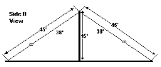
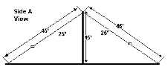
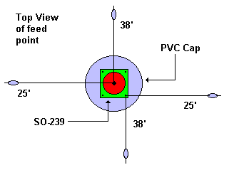

Construction Details
Drill a PVC Cap to accept SO-239 (7/8") and 4ea #6 screws, lock washers and nuts.
Make sure to center the SO-239 in the hole before drilling the 4 screw holes. Lock washers go under the nuts. 3 screws are 1/2" and the other is 1".
Cut off the head of a 1" #6 brass screw and solder it in the center post of SO- 239.
Cut antenna wires to length plus a little
Fit one end of each wire with solder lugs
Fit the other with the egg insulators and parachute cord or other non- conductive rope, which serves as guy ropes on the ends of the 4 elements. Two guy ropes should be at least 7.5' long for the 38 foot antenna wires and 20.5' long for the 25 foot antenna wires. Locate the 4 Plexiglas pieces and drill 3/8" holes on each end. Slip the guy rope through one hole and tie it to the other. See picture on last page if you have trouble visualizing this... These pieces allow you to pull the Plexiglas piece up the guy to shorten it and adjust the tension of each guy. The total length of each element... wire and guy... is about 45 feet.
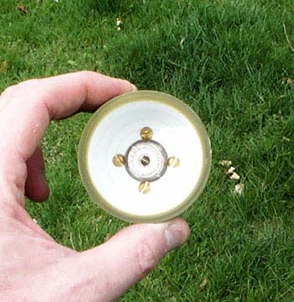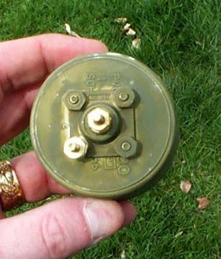

Adaption: (I flipped the OS-239 around to protect the connections with a cap)
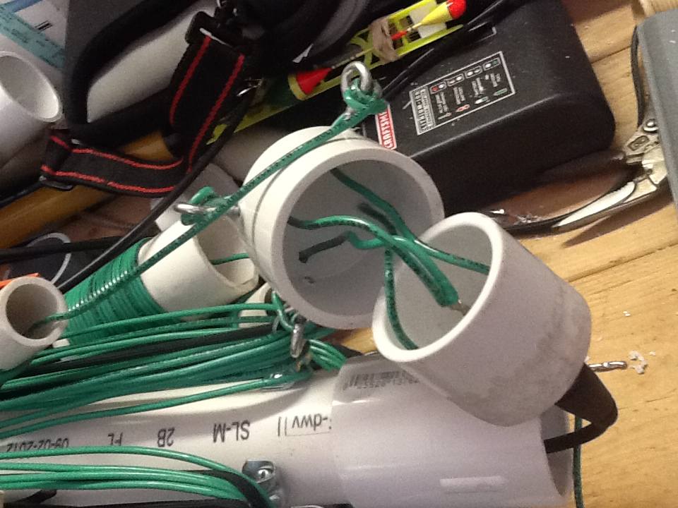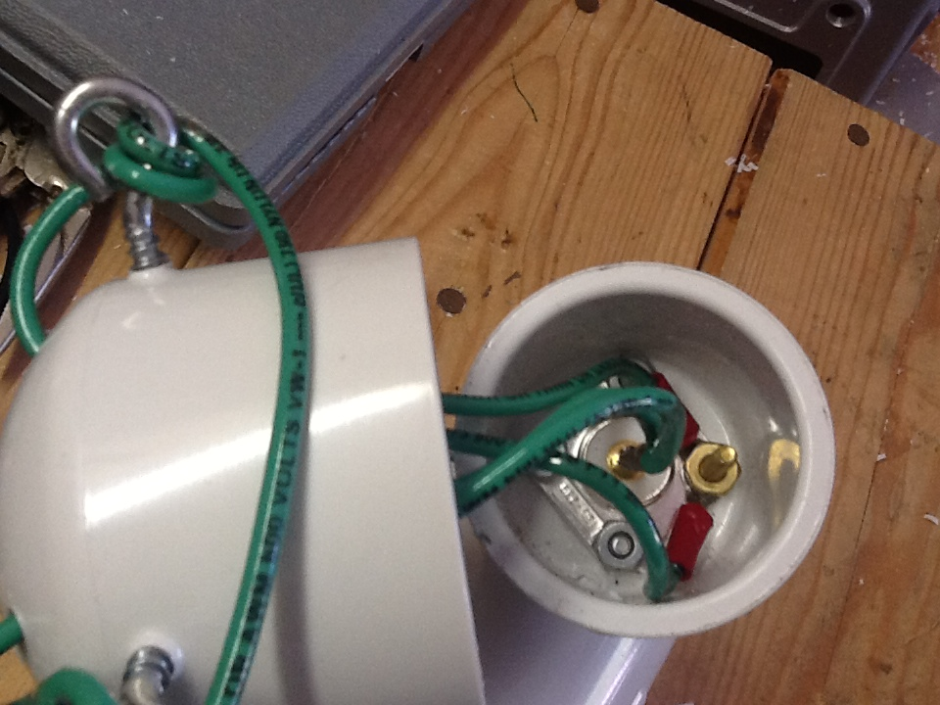
Photo #1
Photo #2
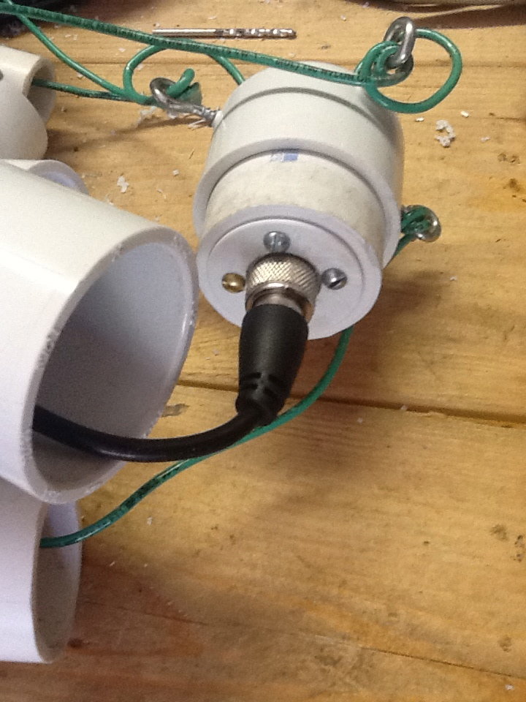
The top is a 1 ½” cap that fits over
the plug.

Eye screws were used to hold the wire
to reduce tenson on the connections inside

Notice photo #1 & #3 that I ground the
edge off the 1 ½” plug to fit inside of the
1 ½” coupling.
Photo #3

Drill hole in center of second end cap (3/4") and run round steel 18" X 3/4" rod through the center. I purchased the rod at Menard's Home Center and it would also be available it Home Depot, Lowes or similar home centers. This is the bottom section and the center stake helps when setting up the antenna.
Drill a 3/4" hole near the bottom of one end of one of the 5' pieces of PVC pipe. After drilling the hole run one end of 17' of RG-58 coax through the pipe and out the hole. Crimp a SO-239 on this end. Crimp a PL-259 on the other end. The long end is run through the pipes before erecting the antenna as a coax feed. Alternately you can just run a long piece of coax to the top but I thought this was quicker and easier. I leave the coax in the bottom section and feed to the connector in the top when I assemble the antenna. You may find it easier to leave the coax in a coil and feed from the top through the bottom.
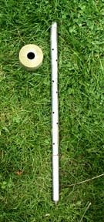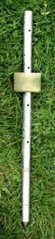

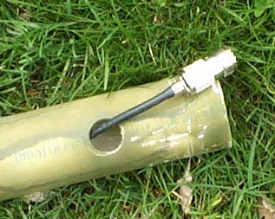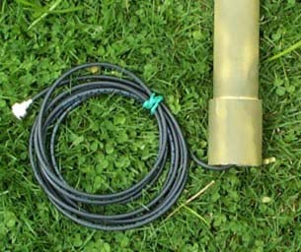
Install pipe coupling to one end of the pipe as seen above. Install a coupling to the remaining pipe as well. The couplings need not be glued... in fact I didn't glue any of the caps or couplings and they seem plenty sturdy for the purposes of the support mast.
Put the top cap with SO-239 on top of what will be the top section of PVC pipe. Attach wire elements to the top cap as shown in the drawings, also illustrated below.
Adaption: I soldered the two load wires to the center
instead of a screw to the SO-239 (see page 4 above)
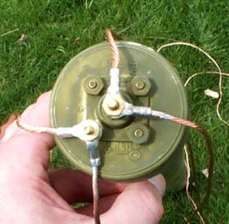
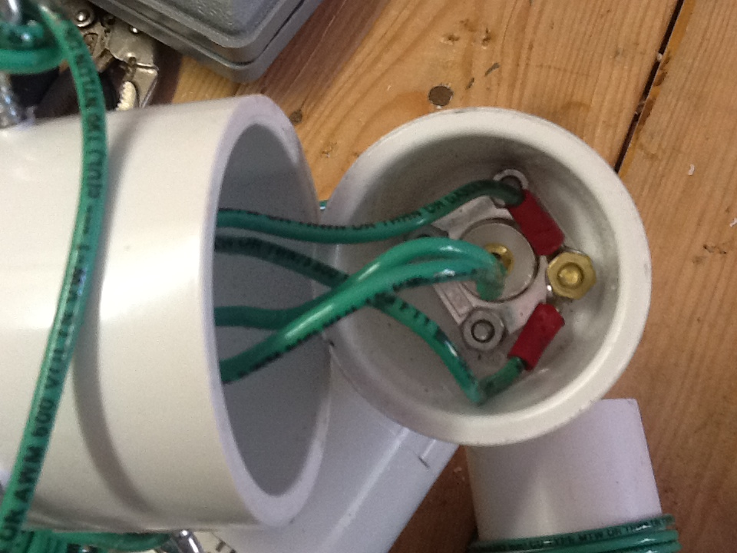

Drive the section with the bottom cap and spike into the ground. Assemble the other two sections together and then hoist onto the lower section. This is MUCH easier with two people but with practice you can assemble it yourself. Just be careful in case it falls over.
Extend the wires as in the diagrams and attach the guy ropes to the stakes. The stakes should be located 42.5 ft from the center mast of the antenna so the wire elements form crossed dipole-like antenna sections. Thread the Plexiglas pieces onto the guy ropes. Snug up the guy ropes to straighten the antenna mast using the Plexiglas pieces you made earlier... they make it easy to adjust the guys. Check out the photos which follow and you'll get a better idea of how to make the Plexiglas guy tensioners. I bought power cord holders at a home center to wrap the wire and guys on and labeled each (38’ or 25’)... they were 2 for a dollar so it was really a deal. Using these for guy and antenna wire storage really helps things stay neat when I break down the antenna and store it in its bag.
The antenna works NVIS mode from about 3.5 to 11 MHz. It's generally necessary to use a tuner with this type of antenna... then it's useful from 2 - 30 MHz.... the high bands are not NVIS however. If you build this antenna let me know how it works for you. I use a LDG Z-11 auto tuner with my Argonaut V and it works great!
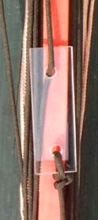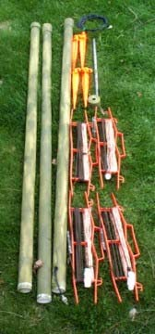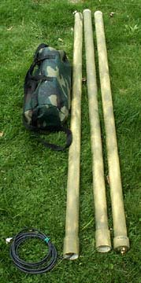

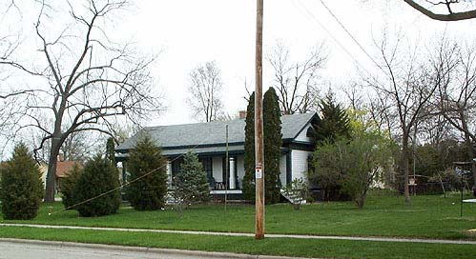

2) Improving the AS-2259 NVIS Antenna By N3AE and N3IDX
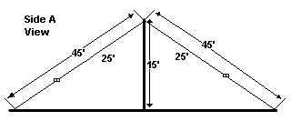
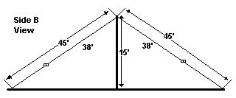
Most CARA members just finished making NVIS antennas for HF emergency service use on 80 and 40 meters. The antenna design is based on the military AS-2259 with the dimensions shown in Figure 1. Further information can be found at W9WIS’s web site. The cross dipole wire lengths of 38 ft and 25 ft provide for a reasonably small antenna footprint but the resonant frequencies are well outside the 40 and 80 meter amateur bands, requiring the use of an antenna tuner.
Figure 1
The antenna was analyzed using EZNEC to determine its basic characteristics and to identify any improvements that could be made. The SWR plot shown in Figure 2 shows the antenna has low SWR only at 5.9 MHz and 9.1 MHz. At 3.820 MHz the antenna has a feed point impedance of 12.51 - j406.4 ohms, leading to a very high SWR. The performance at 7.2 MHz isn’t any better, with a feed point impedance of 923.8 - j205.3 ohms. The high 40 and 80M SWR, as well as the resonances around 5.9 MHz and 9.1 MHz were confirmed on N3IDX’s antenna using an MFJ-259 antenna bridge.
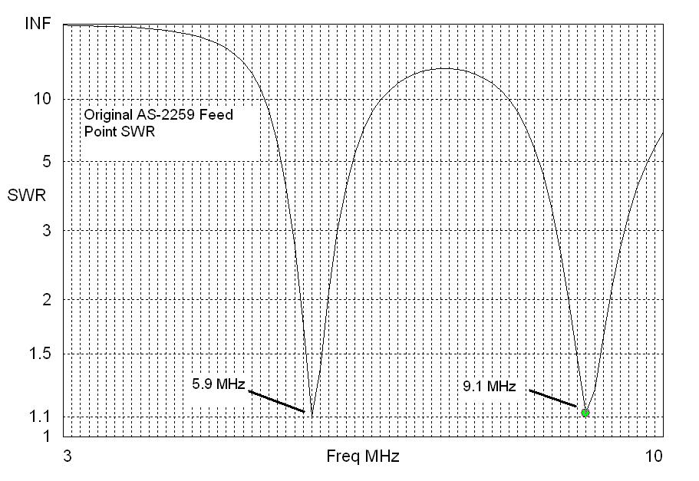

Figure 2
While a good antenna tuner may be able to match the antenna on 40 and 80 meters, the SWR on the coax feedline is very high, leading to high losses well beyond the matched loss of the coax itself. A quick check with a transmission line program shows that on 3.820 MHz, using 100 ft of RG-8X coax, the high SWR adds 11.6 db of loss on top of the basic 0.4 db matched loss of the coax. The total 12 db of loss means that your 100 watt transmitter is only getting 6.3 watts into the antenna. So why does this antenna work for the military? For one thing, the radio is typically right at the bottom of the mast, not many feet away. Also, for the military version (at least the version built by Collins Radio) the mast itself is designed to be a very low loss, large diameter coax transmission line.
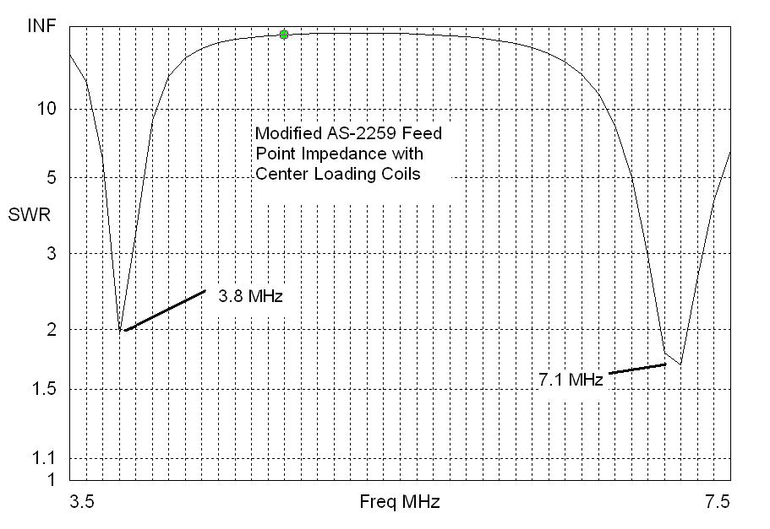
So what can we do to improve this antenna for 40 and 80M amateur use? One solution is to make the antenna elements look longer electrically by adding loading coils near the center of the antenna. EZNEC has a very nice method to add series impedances in the antenna segments. In this case, we need inductive impedance. A bit of trial and error resulted in the much improved SWR plot shown in Figure 3. At 3.8 MHz, the SWR drops to a respectable 2:1. The 40M SWR is even better, dropping to about 1:1.6 around 7.2 MHz.

Figure 3
So how do we make the coils? The formula for a single layer closed-wound inductor can be found in the ARRL handbook . K7MEM has a very nice on-line calculator. The EZNEC derived inductance values were used to build loading coils using PVC pipe for the coil form. The 80M coils use 1.5 inch pipe (which has an outside diameter of 1 7/8 inches). The 40M coils use 3/4 inch pipe (which has an OD of 1.05 inches). Insulated 14 gage house wire was used. After some final tweaking to adjust the number of turns to achieve best SWR as measured by the MFJ-259, we arrived at 14 turns for the 40M coils

and 19.5 turns for the 80M coils. The differences between the EZNEC calculated values (19 turns on 40M; 22.5 turns on 80M) and the final MFJ-259 confirmed values are probably due to errors modeling an antenna this close to the ground, plus the fact that the coil wire leads add length to the overall antenna wire.
The coils are close wound on the PVC pipe and anchored by drilling a small hole through the pipe to pass the end of the wire. One end is mounted to a small screw and nut. The coil system easily installs between the antenna’s end cap and the current antenna wire system. The 40M coil is shown in Figure 4 and the 80M coil is shown in Figure 5. A close-up of the antenna with all four coils installed is shown in Figure 6.
We hope CARA members have found this article useful and will take advantage of the improvements for their NVIS antennas.
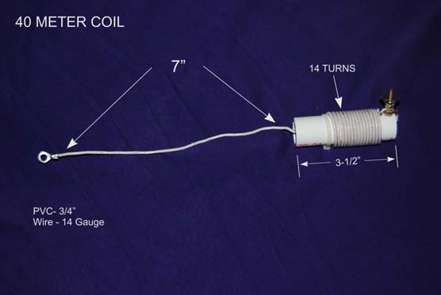

Figure 4

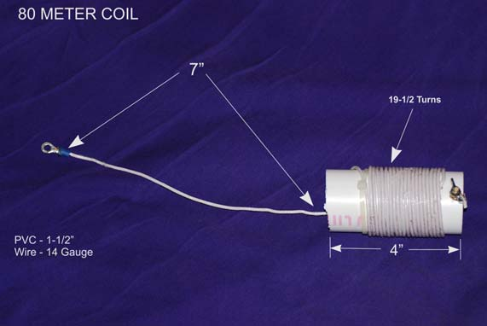

Figure 5
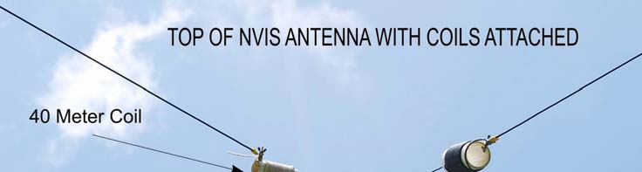

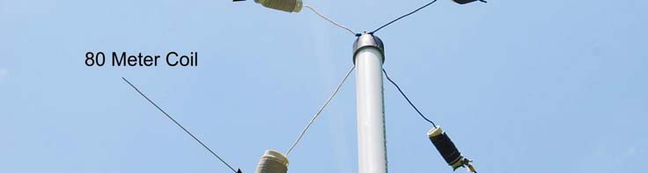

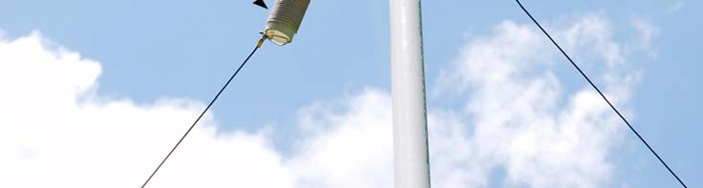

Figure 6

Adaption: (below are photos of my adaptions)

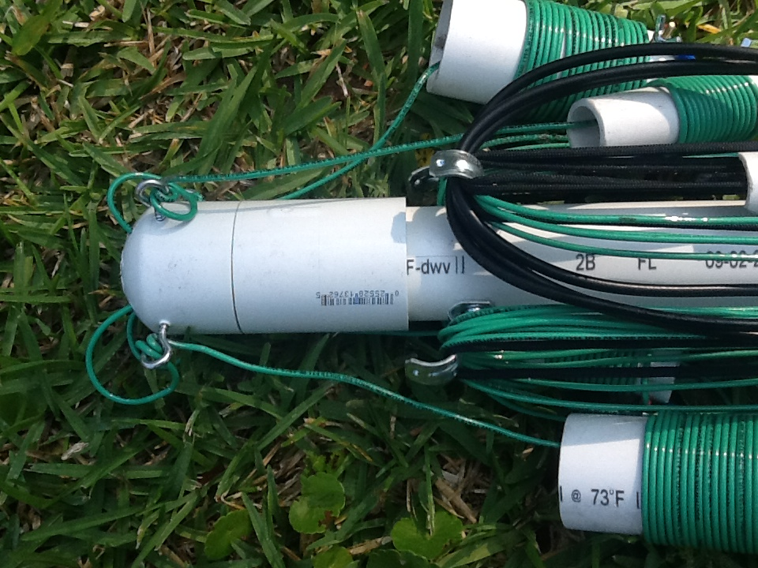
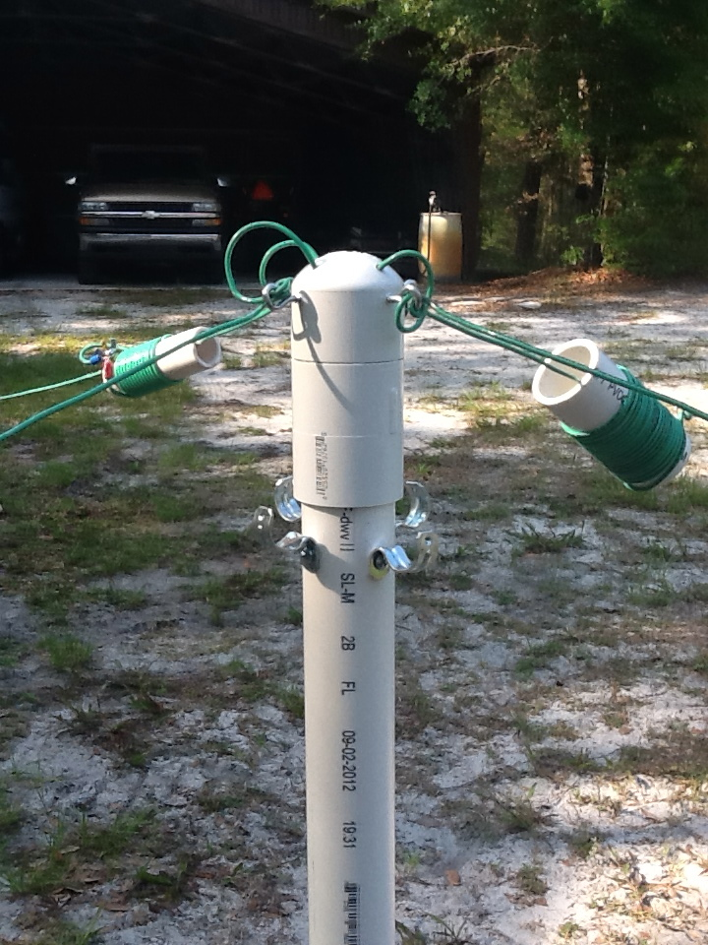

The clips on the side of the PVC are ½” conduit brackets to wrap the wire around.

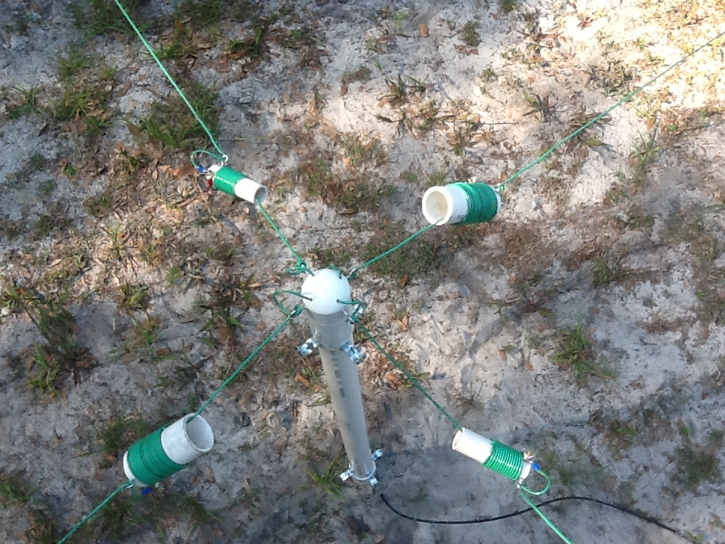

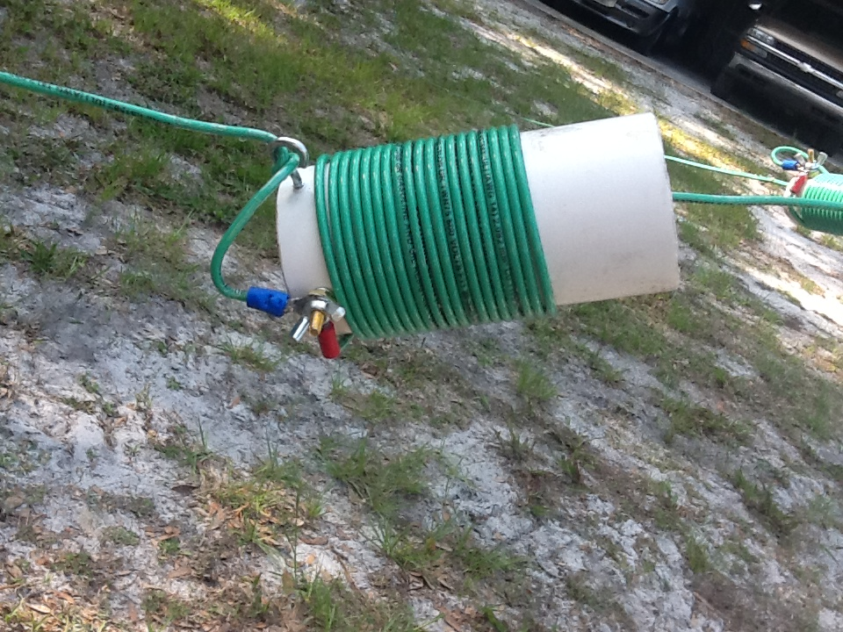
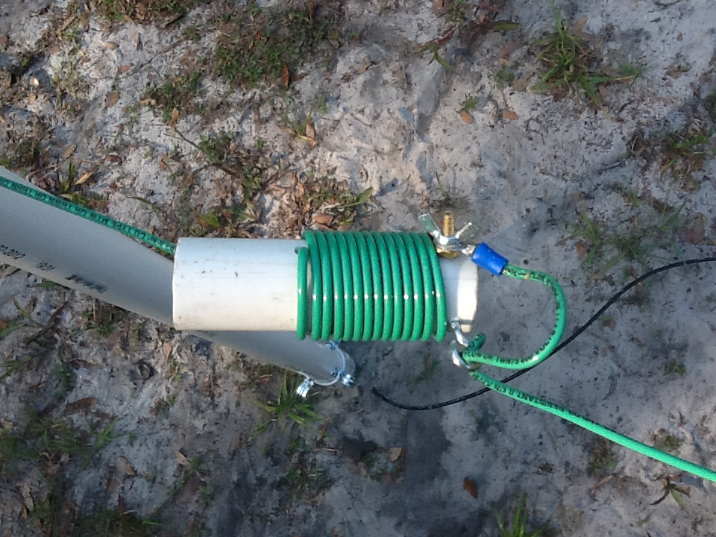

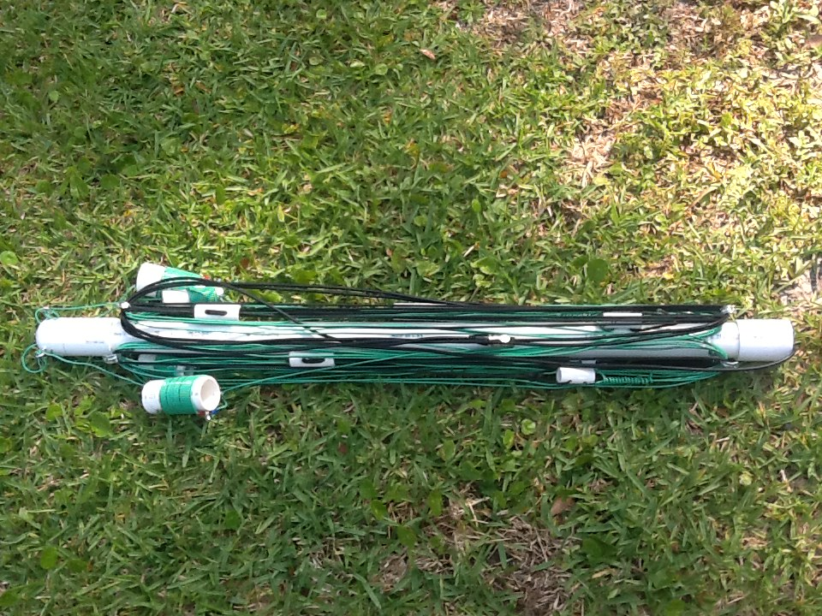
75 meter coil – 19.5 wraps #14 wire around
a 1.5” PVC.
40 meter coil – 14 wraps #14 wire around
a 3/4” PVC.

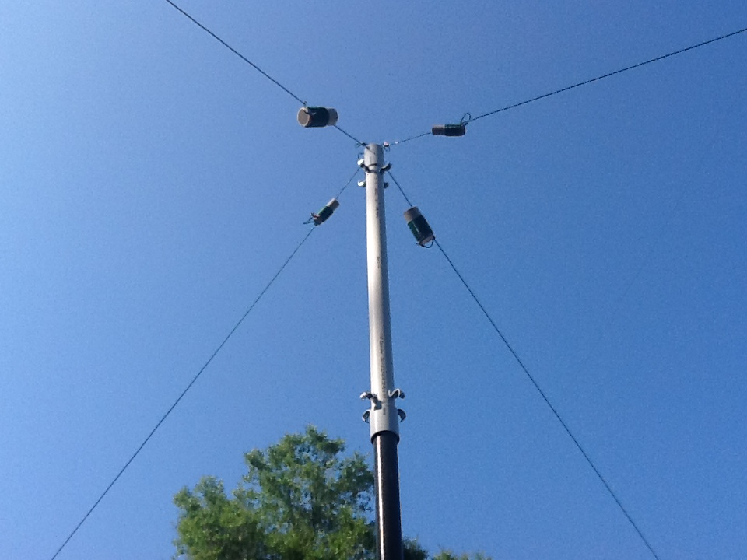
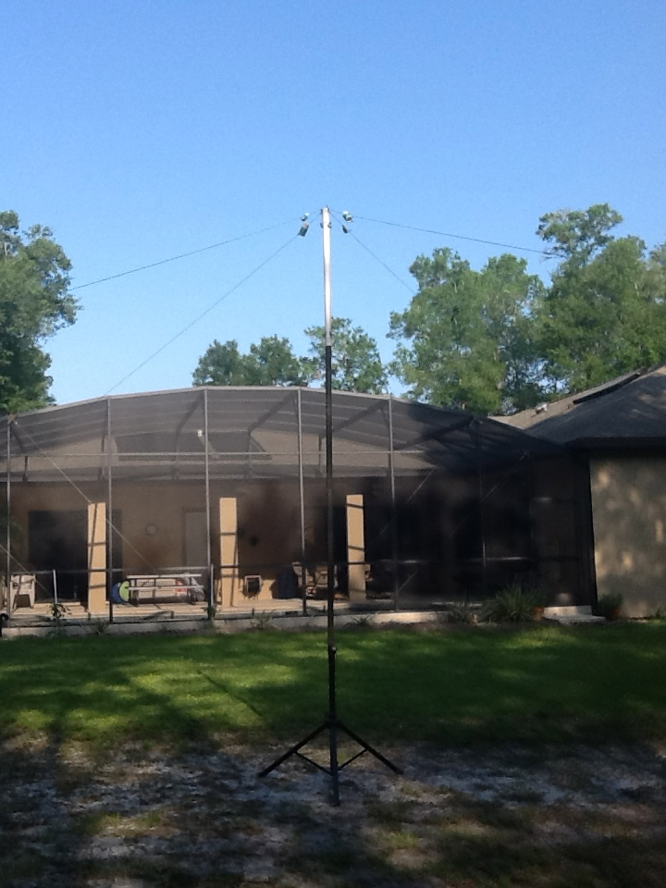

4’ fiberglass tubing
I used 2 pieces
Old Speaker Stand

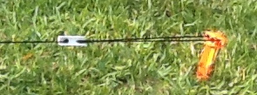
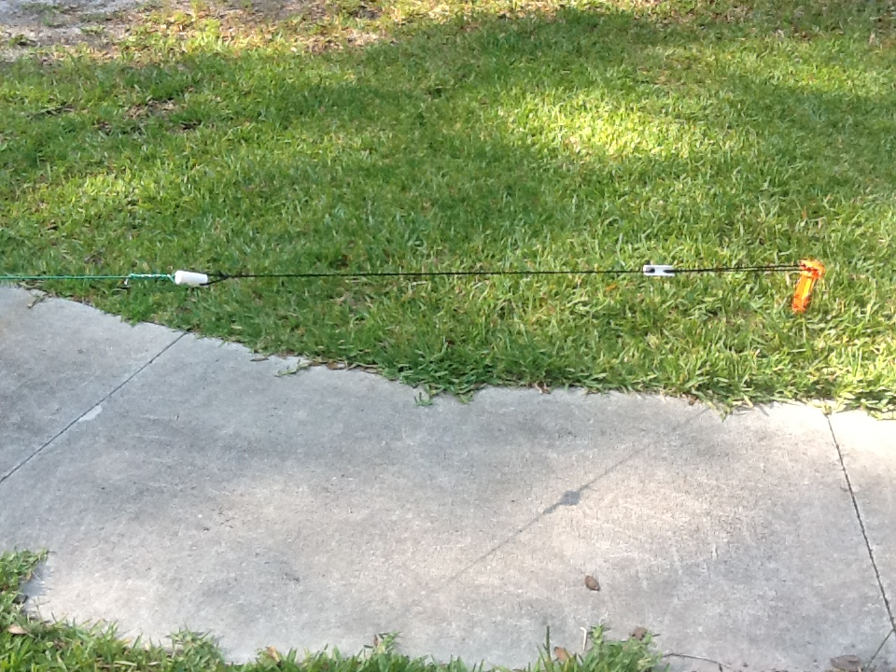
PVC Tighter
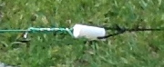
PVC Insulator

Each leg of the 75 meter dipole was 37.8’ to the coil and 11” from the coil to the connections on the SO-239. Each leg of the 40 meter dipole was 27.8’. Using a MFJ-259B the SWR = 1.4 for each dipole on our published frequencies. I can set it up in about 15 min.

The cost is about: $70 if you bought everything new.
Brass screws/nuts = $8.00
#14 stranded wire = $25.00 (bought 500’ for $50. – I used about 170’)
20’ PVC = $10
20’ Coax = $20
SO-239 = $4
Parachute Cord = $8
I use ¾ in PVC for the insulators and ¾” PVC cut in half for the rope tighter.

