YO YO HF Antenna

www.rarcpio.net/e a $50 antenna for $15

 | 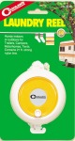 | 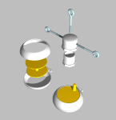 | 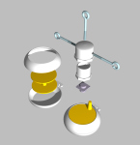 | 

 | 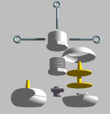 | 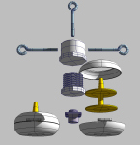 |  | 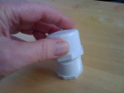

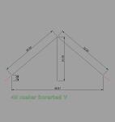

Parts
- 2 Coghlan's Laundry Reels
- 1 PVC plug
- 1 PVC cap (schedule 40 ok) 1 1/2" or 2" fitting are fine
- 1 3/8" x 3" stainless steel eyebolt (we are not using the other eyebolts at this time)
- 100' #18 - #22 AWG stranded hookup wire (Radio Shack $6)
- 1 SO-239 Coax fitting (if using coax - also see coming instructions for balun)

Assembly
- 1) Unscrew the top ring on the laundry reels, counterclockwise, and remove the spools.
- 2) Replace nylon line with #22 AWG wire (Radio Shack 100ft - $6) putting 50' on each reel.
- 3) Reassemble reels and leave 12" of wire out for attaching to the coax fitting.
- 4) Drill two 3/16" hole on either side (180 deg apart) of the plug at the base of the threads for the wires to enter.
- 5) Drill an appropriate size hole in the bottom and mount the SO-239 with the coax threads on the outide (bottom when suspended).
- 6) Attach end of one wire from one reel to the center coax and the other wire from the other reel to the coax shield of the SO-239.
- 7) Screw the 1 1/2 or 2" PVC Cap on the plug having mounted a 3/8" x 3" SS eyebolt onto the cap for suspending the antenna.
- 8) Suspend center of antenna by the eyebolt on the PVC suing strong braided nylon* according to the diagram at 24' in height with the spools attached to supports at 3' AGL and approx 25' from the CL of the center.
- This will yield an antenna perfectly tuned for 40M or, with an antenna tuner, successfully used at 20M and 80M as well. Of course the antenna can be exactly tuned for either of those (and other) frequencies by adjusting the length of the wire extending from each reel according to charts available on the Internet.

Good Luck!

NOTE:: DO NOT use the nylon that comes with the reels for suspending the antenna!! It is very suseptable to UV deterioration and will not hold up ofr more than a week in normal weather conditions.

