Since it's my portable antenna design you are constructing, I suppose I might be able to answer your question how it works.

When you unroll the wire from the reel, it changes resonance in terms of it's operating frequency.

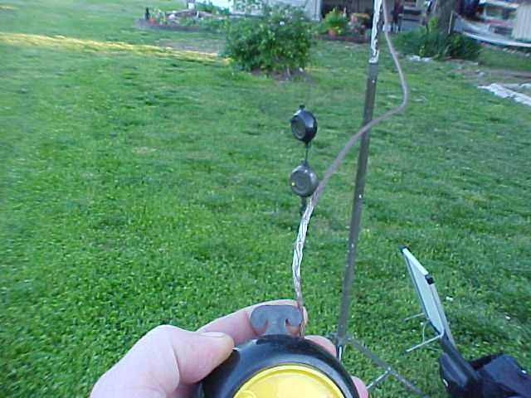

This is the tuning aspect of this design. You will not require an antenna tuner to work every band from 40 - 6m using this antenna.

The wire left inside the reel is really just a "metal ball" which exists at the end of the wire. This "ball" is similar to the one installed on the end of your car antenna.

Bare wire works best for this project because the wire ball inside the camping reels becomes a resonant part of the actual antenna design. It is because of that fact insulated wire will not work for this design.

You need to include the "metal ball" inside as it extends to the rear of the reel as it's a functional part of the actual antenna length.

Design Instructions:

First, start out by designing the entire wire antenna to function on 40m as an ordinary dipole. (around 32' 11' when fully extended from the reels) 14 gauge flexweave is used in this design however "thinner" wire may be used. Stranded is typically better than solid wire because it's usually mechanically stronger and resists kinking etc.

Once we design a 40 m dipole, next, we want to reel in just the right amount of wire for it to reach and function on the 30m band.

For example, since we know a 40m dipole is 32' 11" and if a 30m dipole is 23' 2" long, then we simply subtract the difference and that's where the 30m band will be located on the wire. (subtract around 8' 9" +/- )

Next, check and tweak for best VSWR on the 30m band by adjusting the wire a few inches +/- in or out of the reels on both sides of the dipole until the best VSWR has been achieved at the desired operating frequency.

Next use a paint marker, to mark that spot on each side of the dipole at the point it folds over the tab on the end of the reel for future reference. (see photo below)

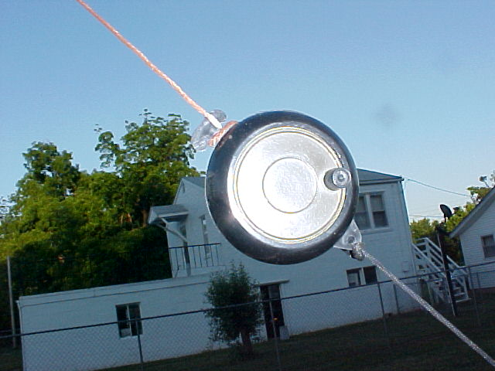

Now "tune" the antenna again but do this calculation for the next band when going from 30m to 20m.

For exmple, to adjust the antenna from 20m to 17m all you need to do is calculate the differences in terms of wire length required between the next two bands in order to find how much wire needs to be reeled up inside. (subtracted.)

For example.

If one leg of a dipole cut for 20m CW portion of the band is:

16' 7" long and if

One leg of a dipole for 17m CW portion of the band is

12' 11" long

And if the antenna has a good VSWR reading on the previous band, then collapse the wire inside the reel exactly 4' 2" and that will be the difference between operating on 20m to 17 meters.

Once you have done that, check the VSWR again, (tweak the wire length and inch in or out of the reel if necessary) and now mark that spot on the antenna wire using the paint marker.

Lather, rinse, repeat.

Do the same thing above but for changing bands from 17 to 15 meters.

Next you adjust and mark the wire going from 15 to 12m

12 to 10m and so on...

Complete the calculations and wire marking procedure on every band until you have markings on your roll up antenna wire for every band from 40m though 6 meters.

You can also include and mark it for 2 meters if you like!

Now to operate on a regular basis using ONE high performance and lightweight portable antenna for every amateur radio band from 40 - 2m AND without requiring any tuner, all you need to do is count how many wire marks it takes to operate on a particular band.

For 40 meter operation, you simply unroll all the wire from the entire reel. (no paint marks required)

30 meters = 1 paint mark on each side of the dipole
20 m = #2 paint mark
17m = #3 paint mark
15m = #4 paint mark

etc etc..

It's just that easy...

Hi Andrey,

Since it's my portable antenna design you are constructing, I suppose I might be able to answer your question how it works.

When you unroll the wire from the reel, it changes resonance in terms of it's operating frequency.

This is the tuning aspect of this design. You will not require an antenna tuner to work every band from 40 - 6m using this antenna.

The wire left inside the reel is really just a "metal ball" which exists at the end of the wire. This "ball" is similar to the one installed on the end of your car antenna.

Bare wire works best for this project because the wire ball inside the camping reels becomes a resonant part of the actual antenna design. It is because of that fact insulated wire will not work for this design.

You need to include the "metal ball" inside as it extends to the rear of the reel as it's a functional part of the actual antenna length.

Design Instructions:

First, start out by designing the entire wire antenna to function on 40m as an ordinary dipole. (around 32' 11' when fully extended from the reels) 14 gauge flexweave is used in this design however "thinner" wire may be used. Stranded is typically better than solid wire because it's usually mechanically stronger and resists kinking etc.

Once we design a 40 m dipole, next, we want to reel in just the right amount of wire for it to reach and function on the 30m band.

For example, since we know a 40m dipole is 32' 11" and if a 30m dipole is 23' 2" long, then we simply subtract the difference and that's where the 30m band will be located on the wire. (subtract around 8' 9" +/- )

Next, check and tweak for best VSWR on the 30m band by adjusting the wire a few inches +/- in or out of the reels on both sides of the dipole until the best VSWR has been achieved at the desired operating frequency.

Next use a paint marker, to mark that spot on each side of the dipole at the point it folds over the tab on the end of the reel for future reference. (see photo below)

Now "tune" the antenna again but do this calculation for the next band when going from 30m to 20m.

For exmple, to adjust the antenna from 20m to 17m all you need to do is calculate the differences in terms of wire length required between the next two bands in order to find how much wire needs to be reeled up inside. (subtracted.)

For example.

If one leg of a dipole cut for 20m CW portion of the band is:

16' 7" long and if

One leg of a dipole for 17m CW portion of the band is

12' 11" long

And if the antenna has a good VSWR reading on the previous band, then collapse the wire inside the reel exactly 4' 2" and that will be the difference between operating on 20m to 17 meters.

Once you have done that, check the VSWR again, (tweak the wire length and inch in or out of the reel if necessary) and now mark that spot on the antenna wire using the paint marker.

Lather, rinse, repeat.

Do the same thing above but for changing bands from 17 to 15 meters.

Next you adjust and mark the wire going from 15 to 12m

12 to 10m and so on...

Complete the calculations and wire marking procedure on every band until you have markings on your roll up antenna wire for every band from 40m though 6 meters.

You can also include and mark it for 2 meters if you like!

Now to operate on a regular basis using ONE high performance and lightweight portable antenna for every amateur radio band from 40 - 2m AND without requiring any tuner, all you need to do is count how many wire marks it takes to operate on a particular band.

For 40 meter operation, you simply unroll all the wire from the entire reel. (no paint marks required)

30 meters = 1 paint mark on each side of the dipole
20 m = #2 paint mark
17m = #3 paint mark
15m = #4 paint mark

etc etc..

It's just that easy...

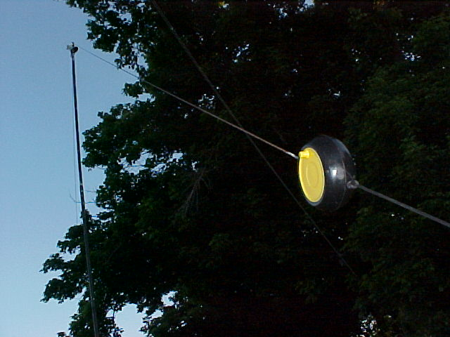

Please let me know if you or anyone else has any questions or needs additional assistance with this portable multiband antenna design.

Please let me know if you or anyone else has any questions or needs additional assistance with this portable multiband antenna design.

